Group 15 master file

Josh Engle

Sam Kondall

Link to code <https://github.com/KingShampoo/MuseamDataBase>

Abstract

We will be cataloging artifacts, such as uniforms, flags, and badges, from Miami Valley Veterans Museum. These items will each be given an individual id and given the following attributes, what kind of artifacts the item is such some form of clothing or a flag, the time-period the item comes from, item national origin, where it was, an approximation of cost, condition, size, date added to the museum and person who donated the item. The expected user, that being people working at the museum, is to be able to find the item, find the donor, find what era the item came from, what exactly is it, when it was added to the museum’s collection, approximant cost, country it was found in, its national origin, current condition, size of the item and sort by any of descriptors listed above. The system should be able to handle up to 2000 different artifacts. In addition, there will be a very simple list the name of the donor, their address and both their phone number and email.

Logo

Data dictionary

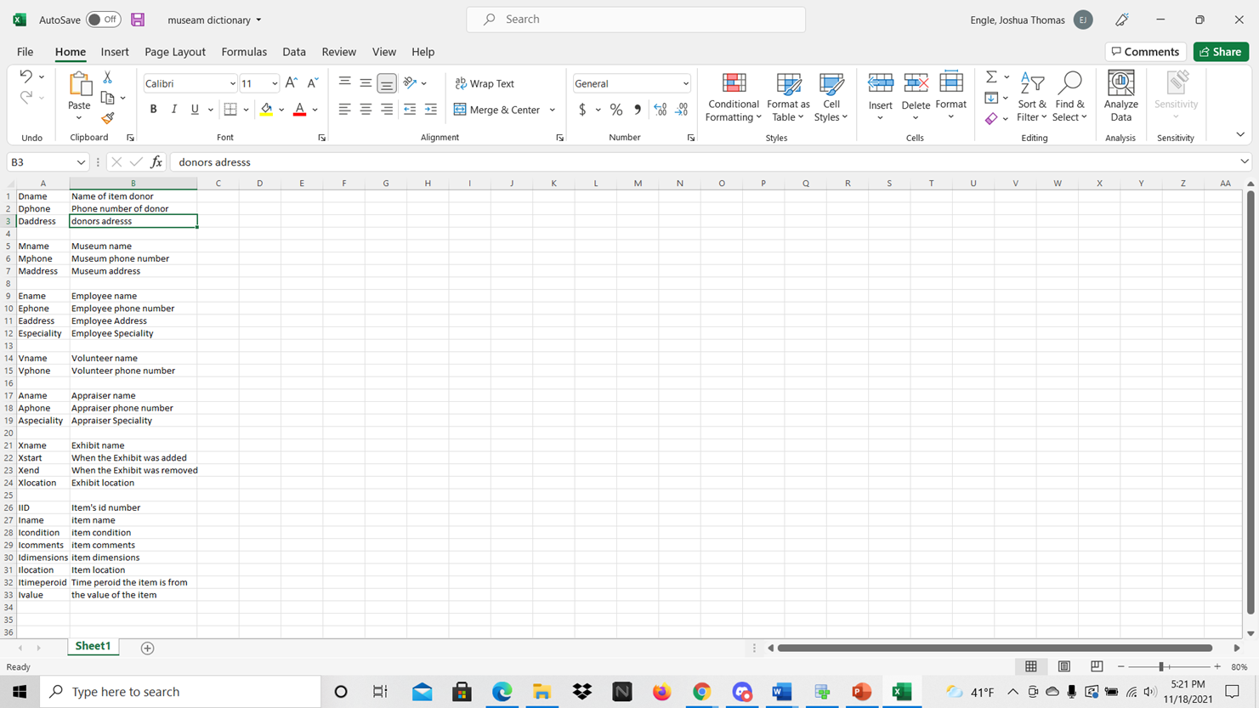

ERD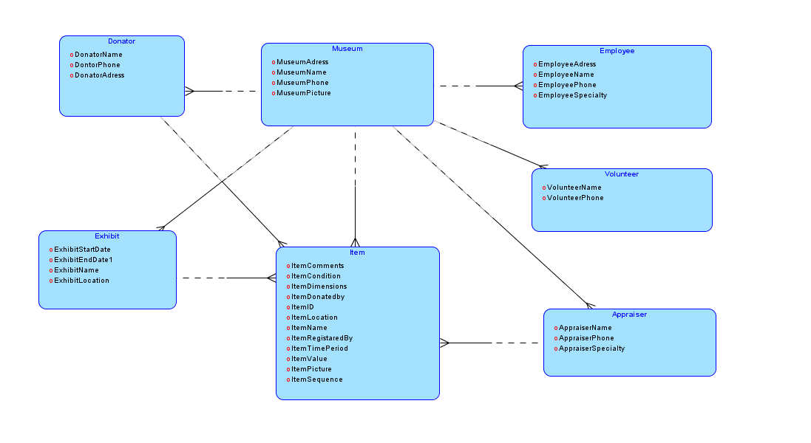

Relational Schema

Donator(DName, DPhone, DAddress)

Museum(MName, MPhone, MAddress)

Employee(EName, EPhone, EAddress, ESpecialty)

Volunteer(VName, VPhone)

Appraiser(AName, APhone, ASpecialty)

Exhibit(XName, XStart, XEnd, XLocation)

Item(IID, IName, ICondition, DName, AName, XName, IComments, IDimensions, ILocation, ITimeperoid, IValue)